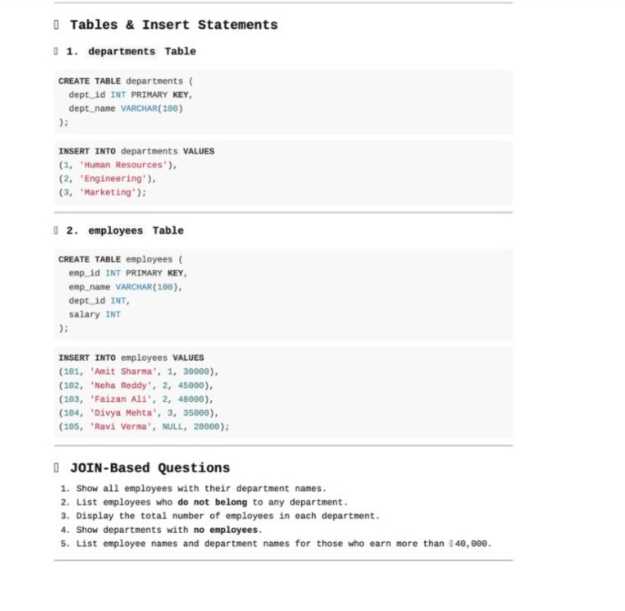1.Show all employees with their department names

select e.emp_name,d.dept_name from employees e left join departments d on

e.dept_id=d.dept_id;

2. List employees who do not belong to any department

select emp_name from employees where dept_id is null;

3. Display total number of employees in each department

select d.dept_name,count(e.emp_id) as total_employees from departments d

left join employees e on d.dept_id=e.dept_id group by d.dept_name;

4. Show departments with no employees

select d.dept_name from departments d left join employees e on

d.dept_id=e.dept_id where e.emp_id is null;

5. List employee names and department names for those who earn more than 40,000

select e.emp_name,d.dept_name,e.salary from employees e left join

departments d on e.dept_id=d.dept_id where e.salary> 40000;